March 16 , 2020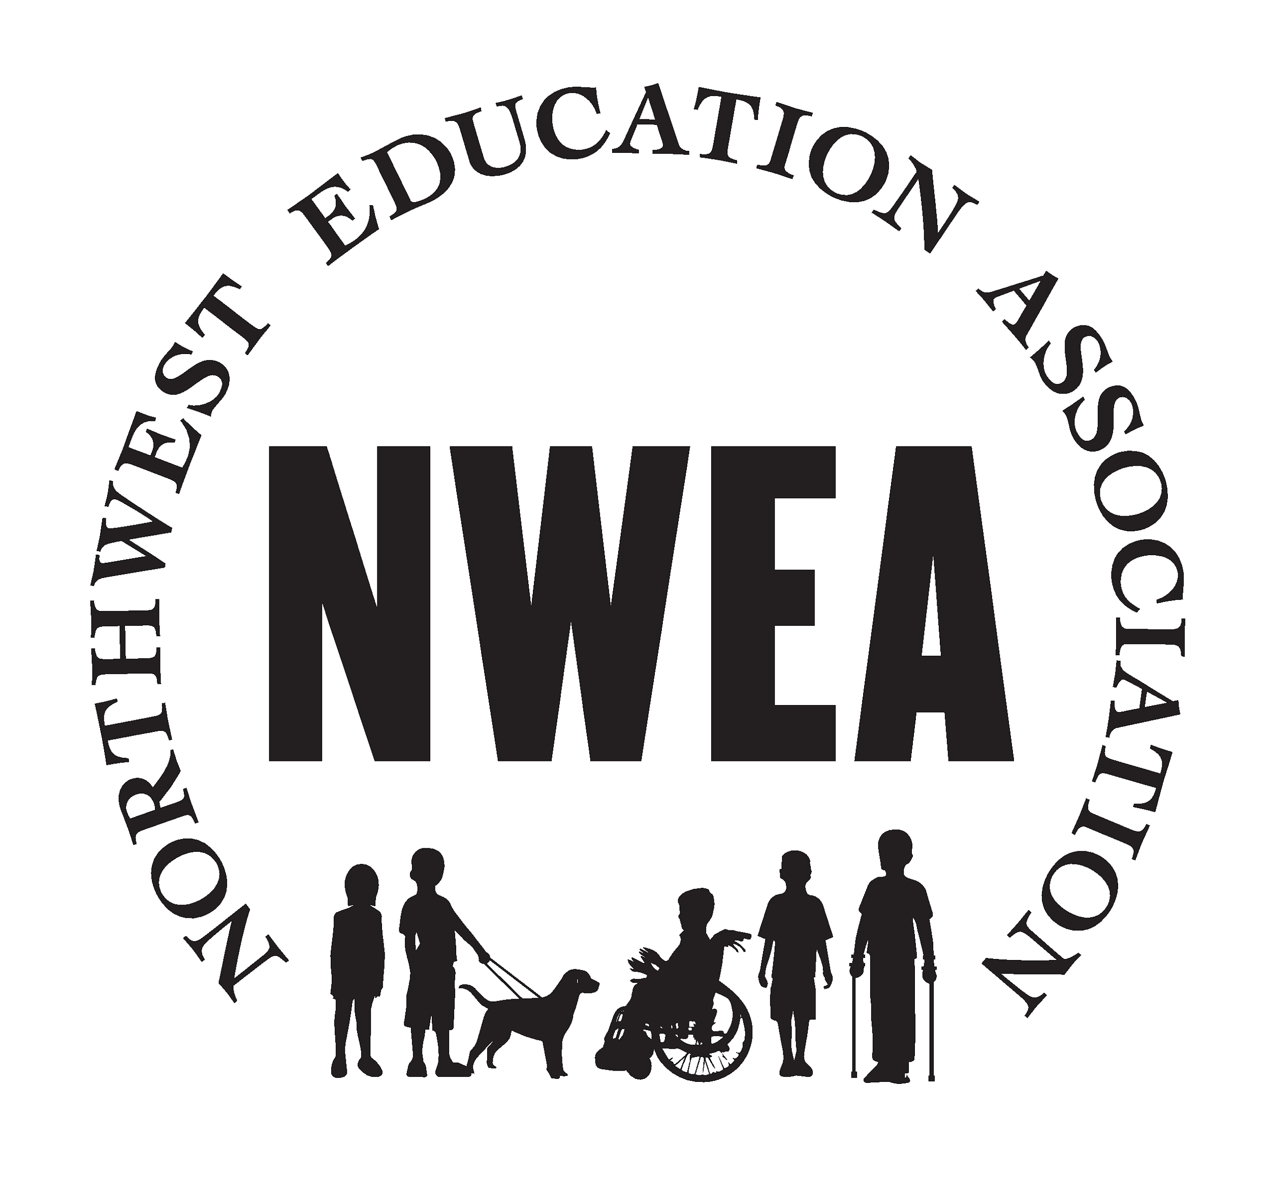

NWEA NEWSLETTER

<https://www.nweducators.org/>

**This month's newsletter you will find:**

* Air quality, hybrid agreement, bargaining, a raffle opportunity and how to get involved

## The Board Would like to Hear from You!

* **Nominations:** Do you know someone who would be a wonderful fit for our Licensed Union Board, or as a building representative? Come help us influence the working conditions and make change for the good of the group. Please let us know if you have someone in mind to nominate! [**contactus@nweducators.org**](mailto:contactus@nweducators.org)

Examples of positions you may want to fill include: Co-President, Vice President, Secretary, and Treasurer. These positions have a stipend attached to them which is distributed at the end of the school year.

* **Unabashed Self-Promotion:** You can nominate yourself, as well, for the board or building representative positions. We love to see that confidence. Email us with interest: [**contactus@nweducators.org**](mailto:contactus@nweducators.org)
* **Meeting Attendance:** Our meetings are run virtually at this time and you, as a member, are welcome to attend. Please ask us if you would like an invitation to join our Zoom meeting (oh goody, one more Zoom meeting): [**contactus@nweducators.org**](mailto:contactus@nweducators.org)

## 

## What the union is working on this month:

* **Air Quality/ filters:** If you are returning to a classroom and you feel that you would like improved air quality above what is being provided, you do have the right to bring in your own portable air filter.
* **MOA/ Hybrid services:** Members voted and many people agreed to the proposed MOA that amended staff notification prior to return to on-site instruction to ten (10) calendar days.
* **Bargaining:** will start March 17th between the union and administration. We are only bargaining for our COLA (cost of living adjustment).
* **Reopening Schools Plan:** largely you will be working with your supervisor on planning for individual situations for providing in-person services is the message we are getting.

## Raffle Time!

* How would you like to be involved more in the Union next year? We’d love to hear your stories! Follow the link to submit and you’ll be entered to win one of our 4 gift cards! Can’t wait to hear from you![Union Survey](https://docs.google.com/forms/d/e/1FAIpQLSeTPrdhcOWiliVn613I_Rk-YX6NbD8IGSPZ-Yl2I-yZ-CkCKg/viewform?usp=sf_link)

## Board Member Spotlight!

We want to introduce each of our board members so you can get to know us better! We will spotlight a board member each month. This month we meet Tina Weeks, Tillamook County VP.

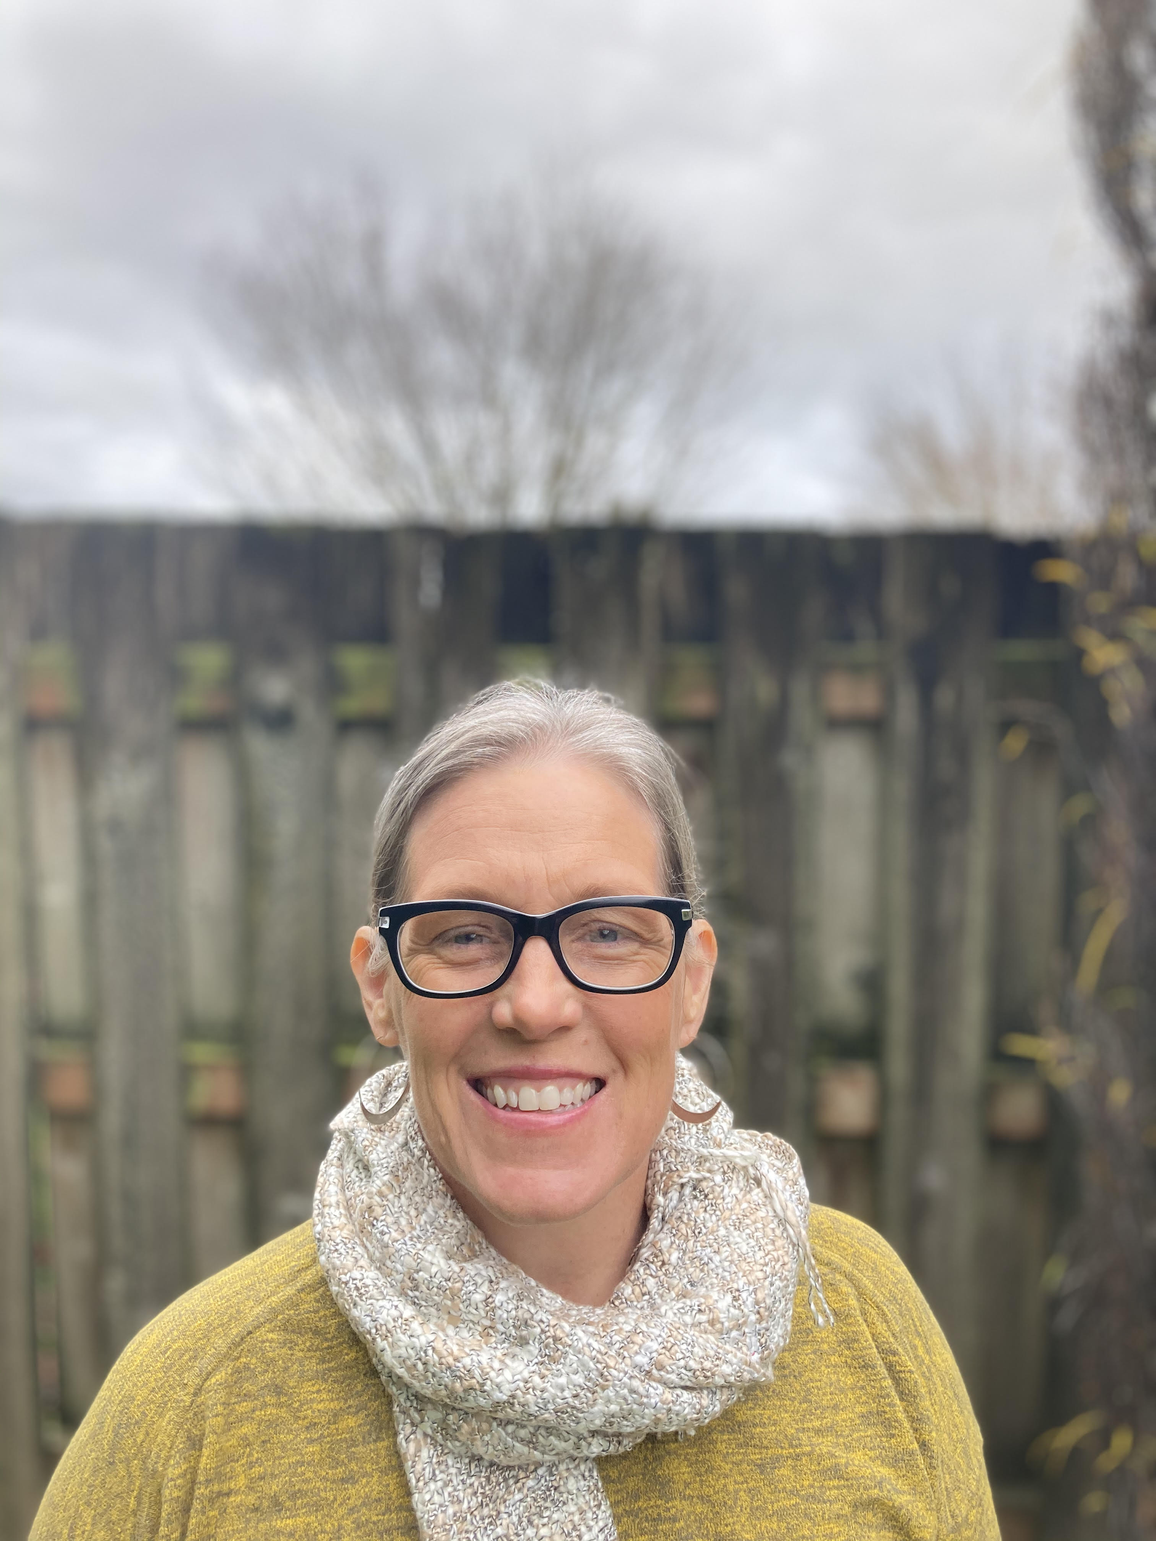

Tina Weeks has worked as a special education teacher and EI/ECSE Specialist for 14 years in various positions in the Tillamook School District and NWRESD. She has enjoyed serving on the school district board and this is her first year as representing NWEA. Tina enjoys time with her husband of 30 years and their five boys on the Oregon coast. She also spends her time making pottery. Thank you for your work, Tina!

**Want to get involved? You can be a building representative, join this year's bargaining team, actively participate in your union! Reach out to a union board member to find out how. Suggestions or questions? Email your union at** [**contactus@nweducators.org**](mailto:contactus@nweducators.org)

## We see you! We know how hard you are working! Thank you :)