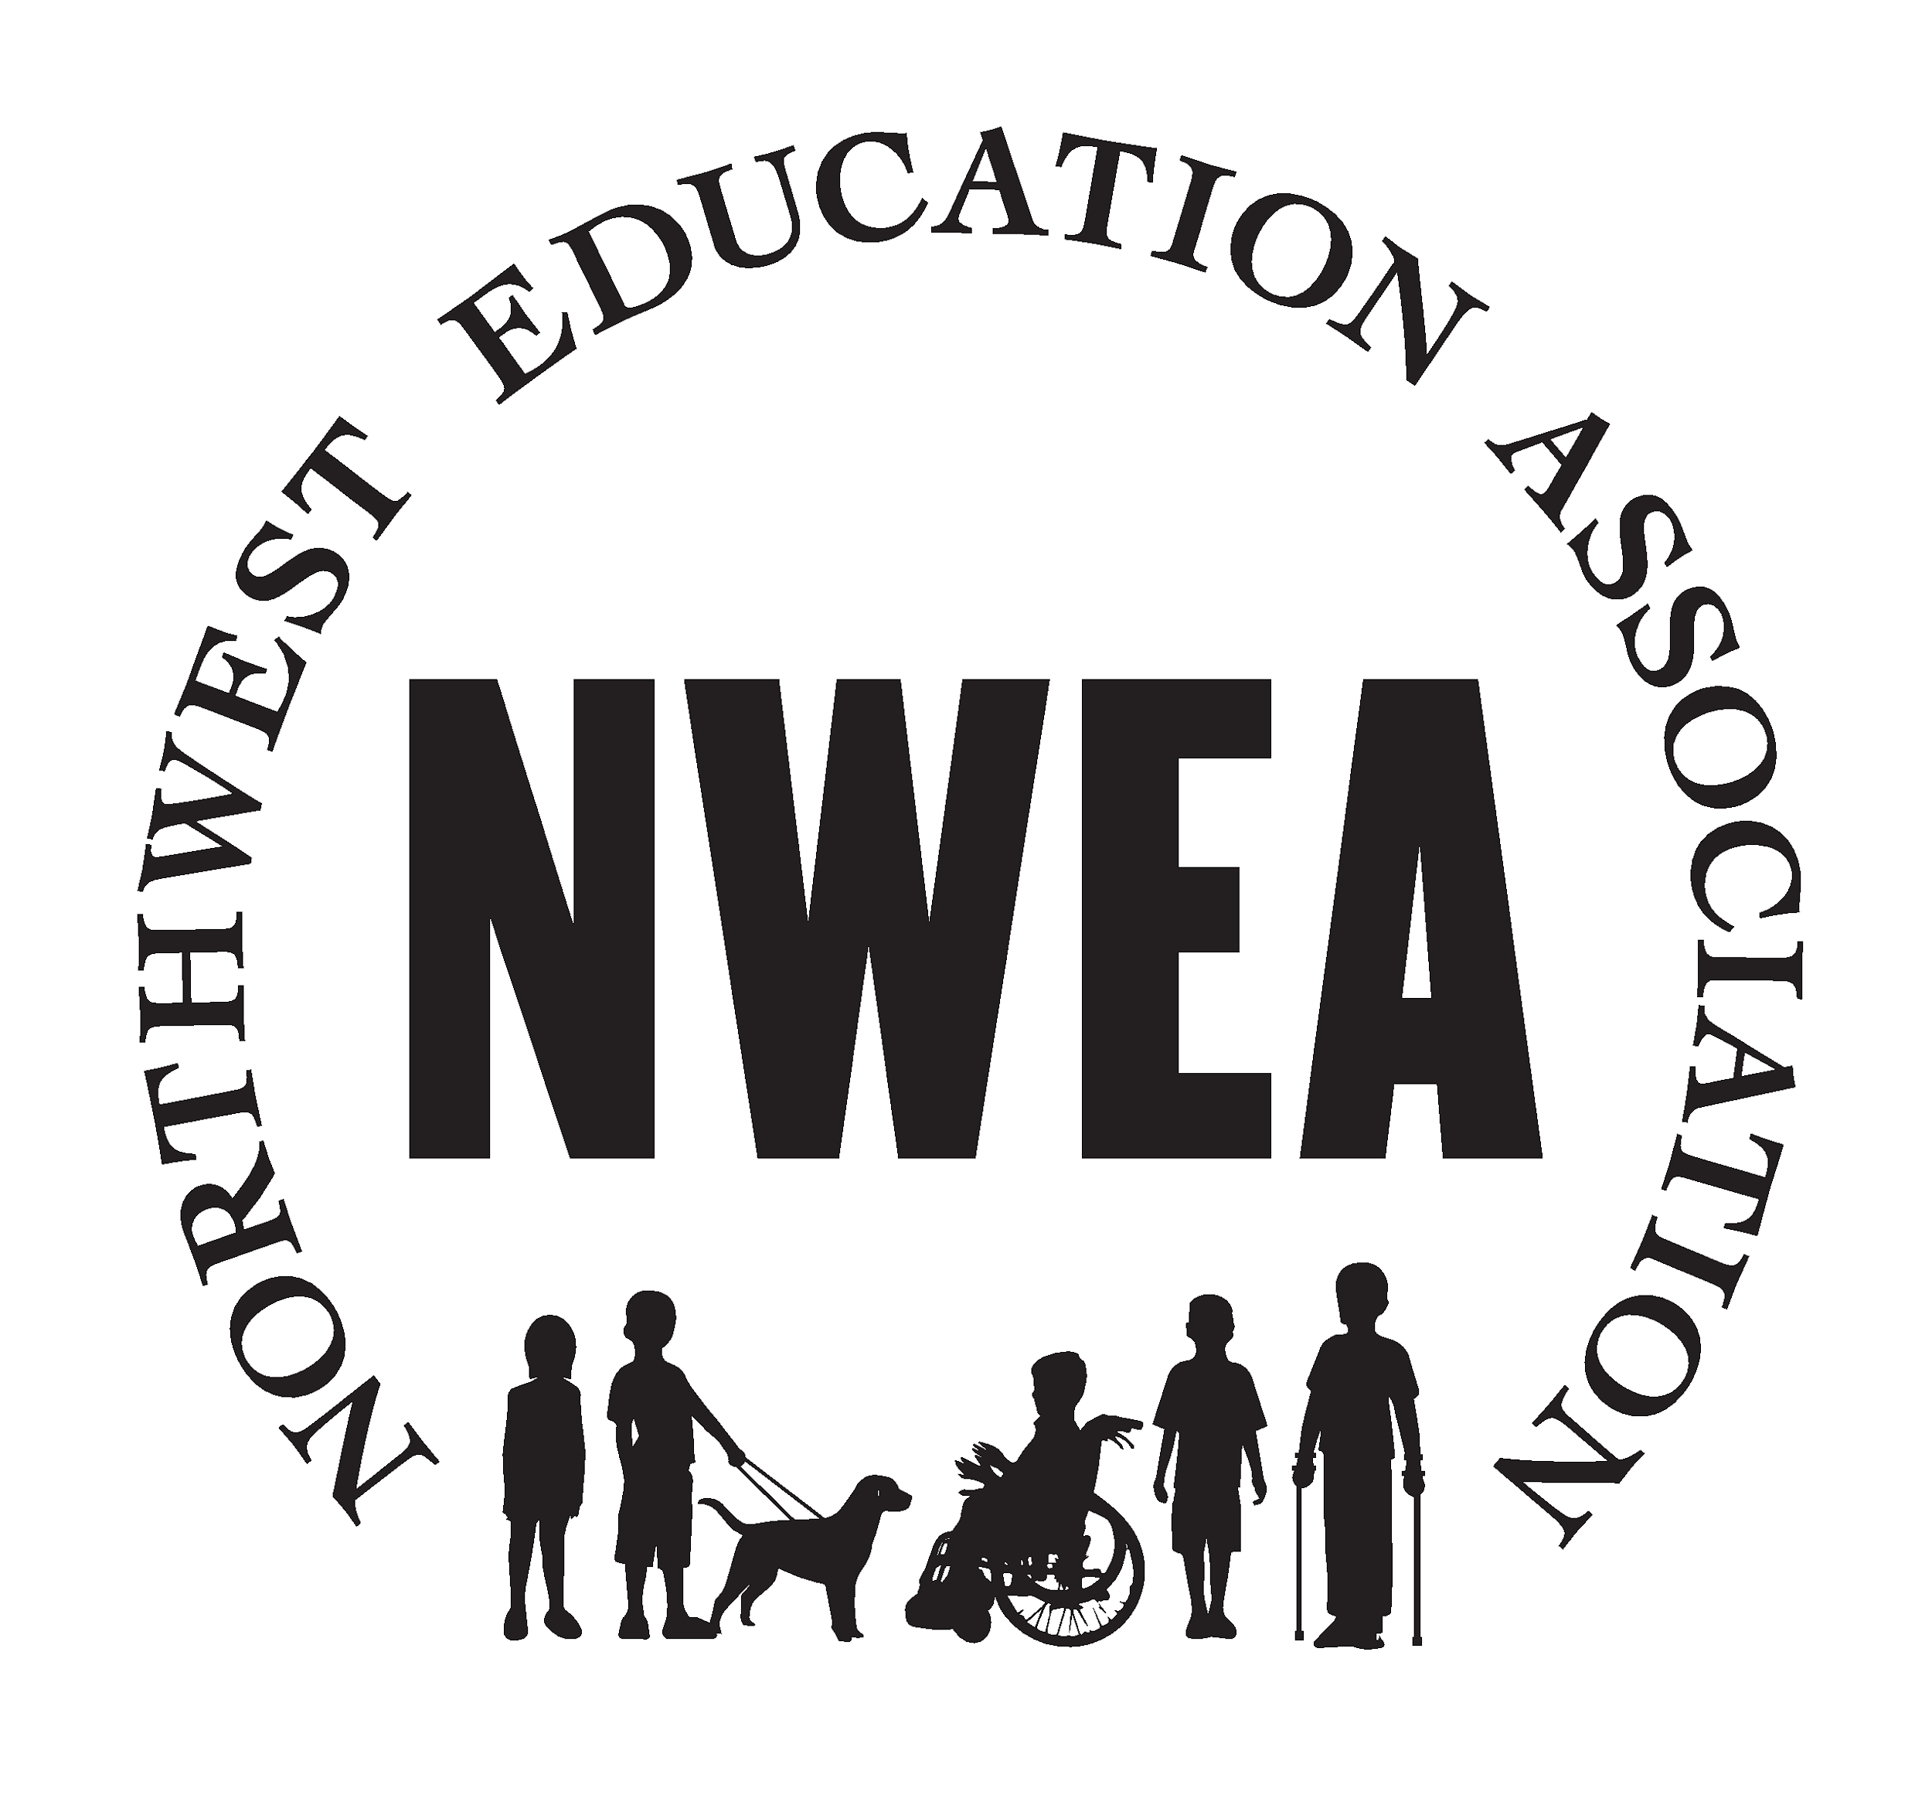
April 20, 2021

NWEA NEWSLETTER
https://www.nweducators.org/
This month's newsletter you will find:
- Bargaining update, licensed appreciation week, Early Enrollment (no, not for health insurance), Elections update, MOU approved

What the union is working on this month:
- Bargaining: Sessions started last month between the union and administration. We are only bargaining for our COLA (cost of living adjustment), a step increase was negotiated last year. Next bargaining session has been scheduled for: April 28th
- Licensed appreciation: Next month is licensed appreciation week and we want our members to be recognized for the work they do. Monday, May 3 and Tuesday, May 4 the ESD will hold virtual events. During these events there will be special thank-you’s given from parents, the ESD board, managers and supervisors. There will be a superhero-themed costume contest, door prize drawings, Bingo, and an agency sponsored luncheon. Also, be sure to check your home mailboxes during the month for a gift from your union.
- Early Enrollment: Do you know someone who was recently hired and/or who hasn’t signed up for the union? Did you know there is an early enrollment membership period where union dues are not due until September 1? Well, it’s true. Some other benefits during this enrollment period are, access to association professional development opportunities and NEA benefit member programs. Early enrollees would become official members on September 1 and would then be able to vote in our elections, ratify collective bargaining agreements, hold elected positions, among other benefits.
- Elections update: Speaking of elections...If you would like to nominate yourself or someone whom you think would be good on the NWEA board, contact Sarah Andrews @ sandrews@nweducators.org. Nominations are due by April 26. Look for ballots in your inbox due by May 3.
- Our MOA for Hybrid was approved by the board this week. It can be found on our website www.nweducators.org under the member resources tab.

Raffle Time!
- And the winners of last month’s raffle on ‘How would you like to be involved more in the Union next year?’ are: Tiffany Hall and Jodi LePla Thanks again for filling out the survey!

Board Member Spotlight!
We want to introduce each of our board members so you can get to know us better! We will spotlight a board member each month. This month we meet Leslie Bispham, Washington County VP.
Leslie Bispham has worked at the ESD for 20 years as a special education teacher at Pacfic Academy (6th-12th grade). She has been involved in all aspects of the program, but especially enjoys planning and coordinating events such as the Halloween party, Komfy Kozy day, as well as all school field trips (she can’t wait to go on field trips again). She is known as “Ms. B'' and over the years has collected many bee-related items from staff and students. Outside of school, she loves to read, garden and do things with her husband and children. She has become quite a cook and baker (when in-person teaching, she bakes all of the staff birthday cakes). Having family that hails from Texas, she enjoys feeding people and specializes in BBQ and Tex-Mex. Leslie is a returning union board member serving as one of your vice presidents for Washington County. Thank you for being a part of our union Leslie!
Want to get involved? You can be a building representative, join next year's bargaining team, and actively participate in your union! Reach out to a union board member to find out how. Suggestions or questions? Email your union at contactus@nweducators.org

We see you! We know how hard you are working! Thank you :)

