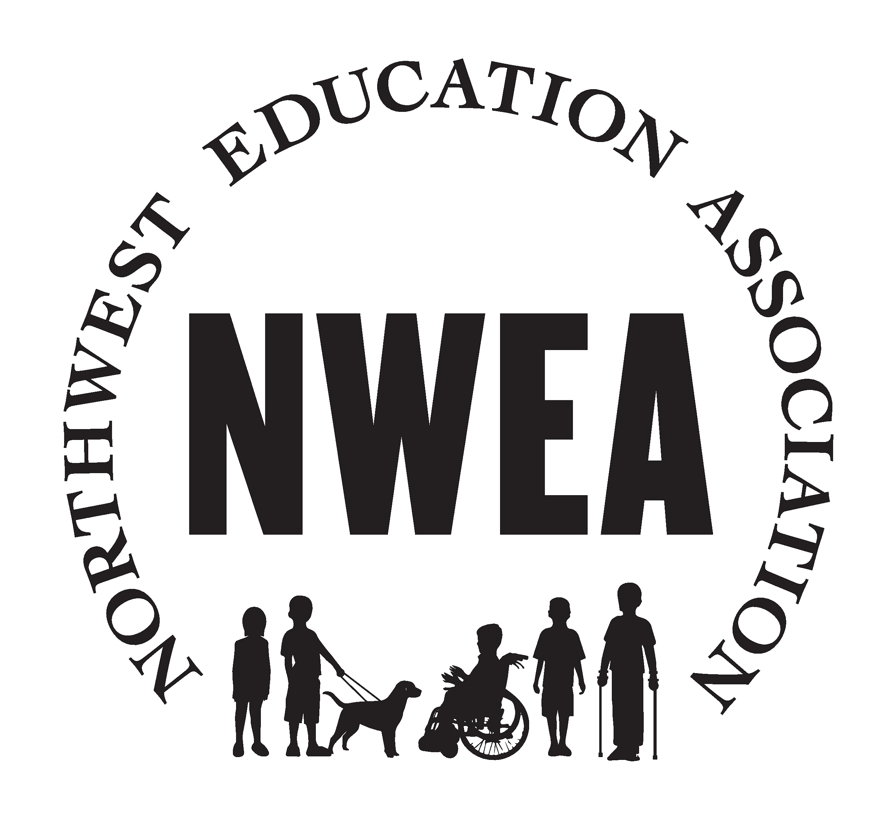
May 17, 2021

NWEA NEWSLETTER
https://www.nweducators.org/
This month's newsletter you will find:
Bargaining/Negotiations update for 21-23 COLA, Recap of Licensed Teacher Appreciation Week, Labor Management, NWEA Elections results, Return to School information, and a Board Spotlight on Jason Talbot, Request for help with union committees (short commitment)

What the union is working on this month:

Bargaining/Negotiations: The negotiation team has been advocating for your COLA increase. We are still actively bargaining and once we reach a tentative agreement it will be sent to all members for a vote. Here’s what you need to know:
The NWEA bargaining unit proposed:
- 4% COLA for the 21-22 school year
- 4% COLA for the 22-23 school year.
The NWEA bargaining unit is proposing this COLA for the following reasons.
- COLA’s have historically been low and are continuing to fall behind the Portland Metro cost of living increases.
- Over the last year, licensed staff have made several sacrifices to support the NWRESD budget including forfeiting personal time, furlough/workshare.
- Staff have been burdened by increases in out-of-pocket expenses due to work from home requirements without reimbursement from the ESD.
- Staff have committed and maintained the ability to deliver HIGH quality instruction to children and families during this challenging time.
- Staff have maintained and helped to solidify NWRESD’s reputation and commitment to being the premier service provider in Oregon.
- This is the time to invest in our staff, to reward them for the amazing work they do and continue to do. This is a way we can support equity and retain
NWRESD bargaining team came back with:
- 1.25% COLA for the 21-22 school year
- 2.0% COLA for the 22-23 school year.

NWRESD bargaining team’s 2nd offer:
- 1.70% COLA dependent on state school fund being 9.3 billion
- 2.0% COLA dependent on state school fund being 9.3 billion
Our team’s response: NOT ADEQUATE… negotiations resume… and will resume June 2. Please send us some testimonials to support our position. These could be about challenges you’ve faced over the last year, the financial impact of buying materials, equipment and supplies to work from home, or it could be how you have taught for 20+ years and are at the top of the salary schedule! We know it is important to have you-your experience and expertise is worth a lot! Email testimonials to sandrews@nweducators.org

Recap of License Appreciation Week-
Thank you for all your hard work and dedication to children and families. Enjoy your Dutch Bros gift card mailed to your home from the NWEA board. We appreciate your hard work! The NWRESD Administration sent Subway gift certificates to your email. Enjoy a cup of Joe and a bite to eat!
Thanks for all you do!

Labor Management Issues-
If you are experiencing any issues in your building, please remember to contact and communicate with your supervisor and if issues are not solved, feel free to contact your building rep or NWEA board for support and guidance. Our MOA for Hybrid was approved by the board. It can be found on our website www.nweducators.org under the member resources tab.

NWEA Elections Results-
The votes have been tallied and we are notifying elected individuals! Your board for the 2021-2022 school year is:
Co-Presidents- Sarah Andrews and Rikkie Schley
Clatsop County VP- Joyce Balint
Columbia County VP-Catherine Steadman
Tillamook County VP- Tina Weeks
Washington County VP- Vanessa Hernandez, Megan Snow, Leslie Bispham, Sarah Davis
At large VPs- Ginger Gamboa and Tiffany Hall
Secretary- Jason Talbot
Treasurer- Elena Barreto

Return to Schools-
Administration is able to and will be asking if you have obtained your COVID-19 vaccination. The reason this is being asked is due to the recent breakouts and for staffing next year. Oregon is an AT WILL State, meaning that employers can make the vaccination mandatory, this is not yet the case for NWRESD, but can be for specific jobs. Be on the lookout for a survey to complete to provide this information.

Board Member Spotlight!
We want to introduce each of our board members so you can get to know us better! We will spotlight a board member each month. This month, meet Jason Talbot.
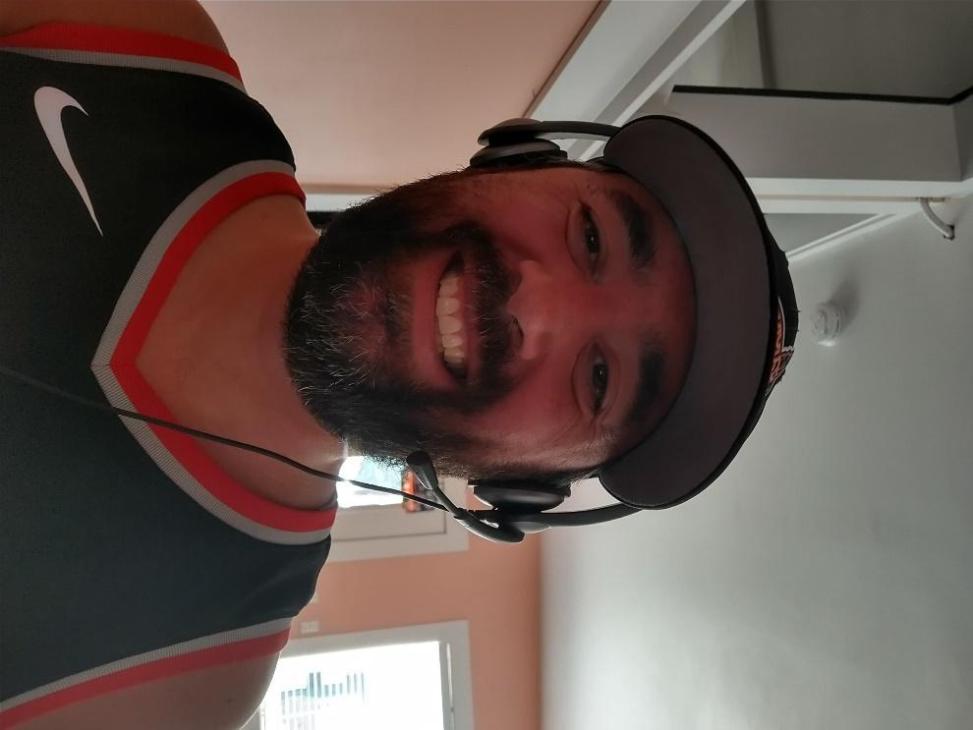
Jason is an ECSE Specialist who teaches at the Hillsboro Early Childhood Center. He has served as the union secretary for the last 4 years where he’s been able to make small gains in his WPM (words per minute) on the keyboard. He enjoys spending time with his girlfriend and 2 young kids (7 year old daughter, 4 year old son). The pandemic caused him to rediscover his golf swing. He is a bit of a fanatic for the following sports teams (Chicago Bears, Atlanta Braves, Portland Trailblazers, Nevada Wolf Pack, and Oregon State Beavers). He also plays the saxophone (alto) and likes to read (mostly non-fiction), usually with a cold beer (IPAs mostly) nearby!

Thank you for being a part of our board Jason!
Want to get involved? You can join the Insurance and Budget Committees! We need your help and you can earn a stipend too! Reach out to a union board member to find out how. Suggestions or questions? Email your union at contactus@nweducators.org

Summer is almost here... Thank you for all your amazing work!

